**Question 1**

Run the API.py code. Take a screenshot of the terminal output. What command did you use to compile and run the code?

Answer 1:

I used the command python api.py to run the application. The below picture was the output

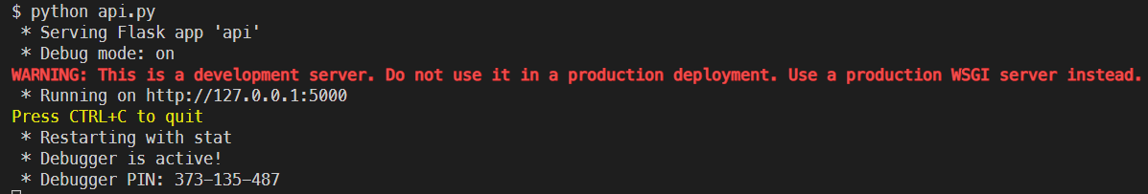

**Question 2**

Run the following command at the terminal prompt: w3m [**http://127.0.0.1:5000/user/Ann**](http://127.0.0.1:5000/user/Ann)

What happens when this command is run, and why?

Answer 2:

The server returned a JSON object containing the Ann user information such as name, age, and occupation. This request used the HTTP GET method to return a response to my request.

**Question 3**

Run the following command at the terminal prompt: w3m [**http://127.0.0.1:5000/user/Adam**](http://127.0.0.1:5000/user/Adam)

What happens when this command is run, and why?

Answer 3:

The server returned a string saying “User not found”. This is once again a GET response to my GET request which asked the server to return the user information of Adam. Since the Adam user does not exist a string was returned from the server.

**Question 4**

What capability is achieved by the flask library?

Answer 4:

The flask library allowed the programmer to create an HTTP RESTFUL API which supports GET, POST, PUT, and DELETE methods.